Ideation Phase
Define the Problem Statements

Date | 30 September 2026
Team ID | SWTID-2026-1669
Project Name | AI WEATHER WISE API
Maximum Marks | 2 Marks

Customer Problem Statement – Weather Wise API
The main customer problem is that users need accurate, real-time, and easy-to-understand weather information for their location. Unreliable or difficult-to-access weather information can make it harder for users to plan their daily activities and prepare for changing weather conditions. The Weather Wise API aims to provide reliable weather data, including temperature, humidity, rainfall, wind speed, forecasts, and weather alerts, so users can make informed decisions based on current and future weather conditions.

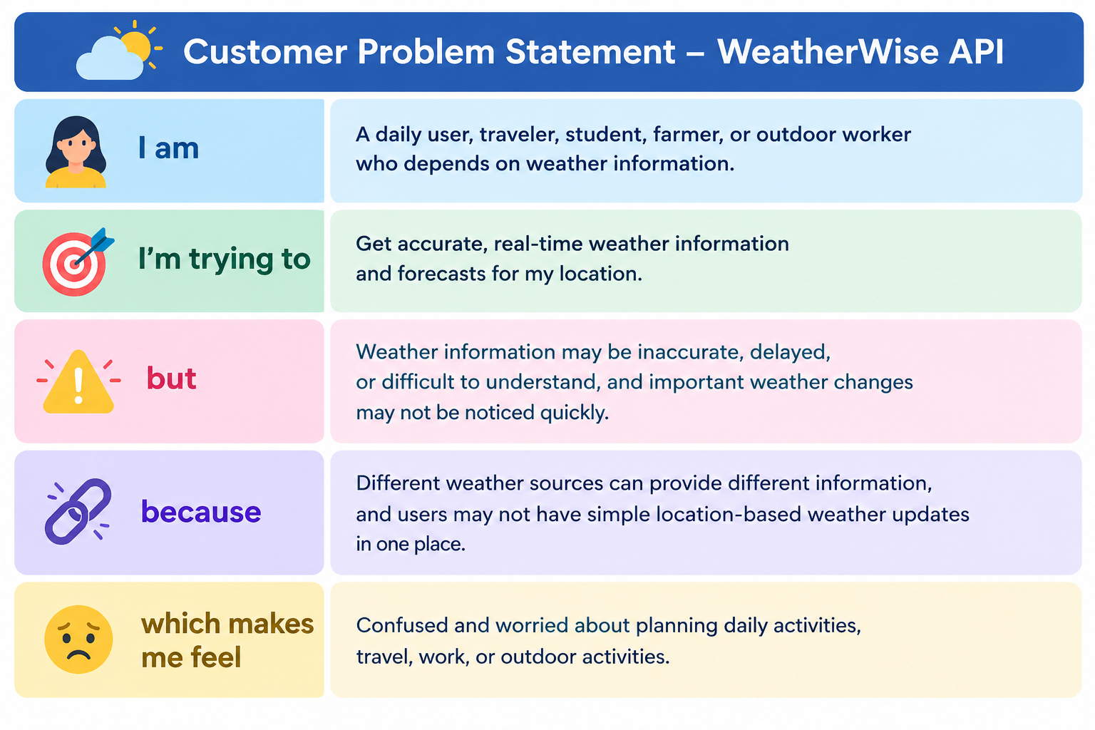

Example:
